Lesson Title: Working for Nuclear Disarmament- Understanding the Present Status

Grade Level: 11 – 12

Unit of Study: Contemporary American Society

Standards - History Social Science
U.S. History 11.9.3
Students analyze U.S. foreign policy since World War II.
Trace the origins and geopolitical consequences (foreign and domestic) of the Cold War and containment policy, including the following: Atomic testing in the American West, the “mutual assured destruction” doctrine and disarmament policies.
U.S. Government 12.3.2
Students evaluate and take and defend positions on what the fundamental values and principles of civil society are (i.e., the autonomous sphere of voluntary personal, social, and economic relations that are not part of government), their interdependence, and the meaning and importance of those values and principles for a free society. Explain how civil society make it possible for people, individually or in association with others, to bring their influence to bear on government in ways other than voting and elections
Standards Language Arts Language Arts
Grade 11 and 12
Writing - Research and Technology
1.6 Develop presentations by using clear research questions and creative and critical research strategies (e.g., field studies, oral histories, interviews, experiments, electronic sources).
2.4 Write historical investigation reports:
a. Use exposition, narration, description, argumentation, or some combination of rhetorical strategies to support the main proposition.
b. Analyze several historical records of a single event, examining critical relationships between elements of the research topic.
c. Explain the perceived reason or reasons for the similarities and differences in historical records with information derived from primary and secondary sources to support or enhance the presentation.
d. Include information from all relevant perspectives and take into consideration the validity and reliability of sources.
e. Include a formal bibliography.
2.0 Speaking Applications
2.2 Deliver oral reports on historical investigations.
2.4 Delivery multimedia presentations

Key Concepts:
“mutual assured destruction” doctrine Nuclear free zones Nuclear proliferation disarmament nuclear-free world

Setting the Context:

The atomic bomb was the pivotal development of World War II. With the decision to use atomic bombs on Japan, the United States ushered the world into the nuclear age. However, students have little knowledge of what this all means. Students must have adequate information to make informed decisions. They need to know about the devastating impact of the atomic bombs on the people of Hiroshima and Nagasaki. The horrific consequence of unleashing nuclear weapons is not the topic of class discussion. This is a difficult but necessary lesson to teach.

During the Cold War the competition between the United States and the Soviet Union led to a weapons race. The possession of nuclear weapons was then viewed as the best means to assure the nation’s security. It was believed that Mutual Assured Destruction (MAD) the ability to inflict an unacceptable degree of damage upon each other even after absorbing an initial attack; would deters both sides from starting a nuclear war.

Attitudes have changed. Knowing the threat posed by nuclear weapons, efforts are increasing to rid the world of nuclear weapons. Attempts to do so are mirrored in the Non-Proliferation Treaty signed by over 180 nations. In January 1992, the Security Council of the United Nation announced, “..the proliferation of all weapons of mass destruction constitutes a threat to international peace and security.”

Former Secretaries of State Henry Kissinger and George Shultz have joined with former Secretary of Defense William Perry and former chair of the Senate Armed Services Committee Sam Nunn in pressing for a new approach to US nuclear policy. They wrote in a January 2007 Wall Street Journal article, “We endorse setting the goal of a world free of nuclear weapons and working energetically on the actions required to achieve that goal.”

Nuclear policy has been viewed as the arena of officials—government and military. However, the nuclear threat is such that everyone should be informed and motivated to work to end the use of nuclear weapons. This lesson provides a brief background on the “nuclear club,” and the stockpile of nuclear weapons that they possess.

Since 9/11, the threat of nuclear disaster has been increased. The possibility that a nuclear device will fall into the hands of a rogue state or a terrorist group raises the need for information and action.

Expected Learning Outcomes: Students will be able to:

- Cite reasons why nuclear weapons pose a growing threat to humankind
- Recount information about the membership of the “nuclear club”.
- Analyze information from various websites to describe present status of nuclear weapons disarmament (who has what)

Essential Vocabulary: This lesson provides an opportunity to define and discuss a number of terms important to an understanding of the nuclear threat. Definitions of terms can be obtained by going to:

Atomicarchive.com at http://www.atomicarchive.com/Glossary/

“nuclear club” designated nuclear weapons states non-proliferation NPT –Non-proliferation Treaty deterrence nuclear free zones

PROCEDURE

Guided Instruction

Use the 1983 film War Games to introduce this lesson. Select the ending sequence which features a

The U.S. master computer going through all the nuclear war scenarios that it has devised, (very dramatic scene of incoming missiles) which all end with no winner. The computer learns that "the only winning move is not to play" CNN’s Cold War: Nuclear Club Who has the bomb, Who has tested it provided the following information:

Members of Nuclear Club | Arsenal # of warheads | Missile Range
United States | 12.000 | 8, 100 miles
Russia | 22,500 | 6,8000 miles
United Kingdom | 380 - 400 | 7,500 miles
France | 450 - 510 | 3,300 miles
China | 400 - 425 | 6,800 miles

Provide students with a map of the world. Label the U.S. and Russia. Based on the missile range given in the chart, ask: What countries would fall within the target zone of each? Have students list.

Note that other countries also possess nuclear weapons (For your information India, Pakistan and South Korea have conducted nuclear tests – Israel is believed to have nuclear weapons though it has not conducted any tests) may also nuclear weapons,

If you have internet access, have students go to the Council on Foreign Relations http://www.cfr.org/publication/12050/#2 and read the article The Growing Nuclear Club by Kathleen Sutcliff. Have students add to the above chart.

Assessment: Students demonstrate their understanding of the issues in this lesson by developing a Powerpoint presentation about the nuclear threat. Present your findings to a class.

Service Learning:
Develop a sample letter addressed to your local congressperson supporting nuclear weapons reduction.

Reflection on Service Learning: After completing the activities students should take time to reflect and write their feelings on goals of the activity and the degree of successful completion; any personal feelings and experiences that occurred during the activity.
Primary Source Document activity: Use the Written Document Analysis Worksheet available from the National Archives Designed and developed by the Education Staff, National Archives and Records Administration Washington, DC 20408 Download from http://www.archives.gov/education/lessons
ANALYZE THE TREATY ON THE NON-PROLIFERATION OF NUCLEAR WEAPONS

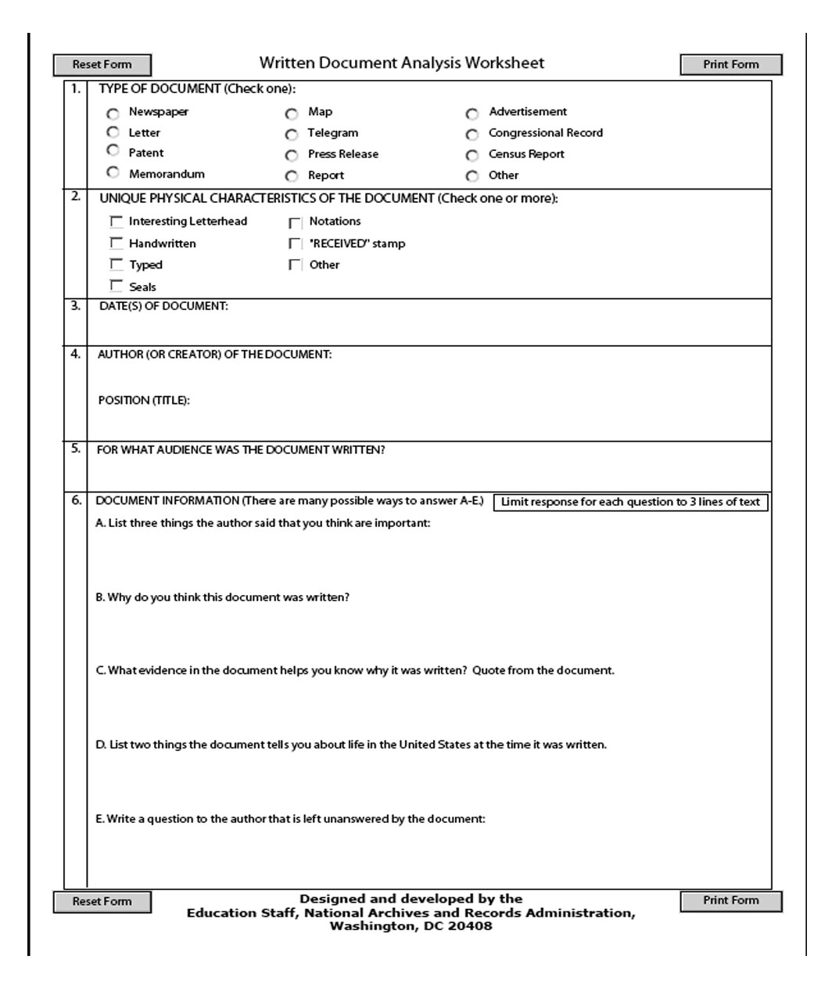
PRIMARY SOURCE DOCUMENT: Treaty on the Non-Proliferation of Nuclear Weapons

Entered into force: 5 March 1970

Depositary Governments: Russian Federation, United Kingdom of Great Britain and Northern Ireland and
United States of America

The States concluding this Treaty, hereinafter referred to as the "Parties to the Treaty",

Considering the devastation that would be visited upon all mankind by a nuclear war and the consequent need to make every effort to avert the danger of such a war and to take measures to safeguard the security of peoples,

Believing that the proliferation of nuclear weapons would seriously enhance the danger of nuclear war,

In conformity with resolutions of the United Nations General Assembly calling for the conclusion of an agreement on the prevention of wider dissemination of nuclear weapons,

Undertaking to co-operate in facilitating the application of International Atomic Energy Agency safeguards on peaceful nuclear activities,

Expressing their support for research, development and other efforts to further the application, within the framework of the International Atomic Energy Agency safeguards system, of the principle of safeguarding effectively the flow of source and special fissionable materials by use of instruments and other techniques at certain strategic points,

Affirming the principle that the benefits of peaceful applications of nuclear technology, including any technological by-products which may be derived by nuclear-weapon States from the development of nuclear explosive devices, should be available for peaceful purposes to all Parties to the Treaty, whether nuclear-weapon or non-nuclear-weapon States,

Convinced that, in furtherance of this principle, all Parties to the Treaty are entitled to participate in the fullest possible exchange of scientific information for, and to contribute alone or in co-operation with other States to, the further development of the applications of atomic energy for peaceful purposes,

Declaring their intention to achieve at the earliest possible date the cessation of the nuclear arms race and to undertake effective measures in the direction of nuclear disarmament,

Urging the co-operation of all States in the attainment of this objective,

Recalling the determination expressed by the Parties to the 1963 Treaty banning nuclear weapons tests in the atmosphere, in outer space and under water in its Preamble to seek to achieve the discontinuance of all test explosions of nuclear weapons for all time and to continue negotiations to this end,

Desiring to further the easing of international tension and the strengthening of trust between States in order to facilitate the cessation of the manufacture of nuclear weapons, the liquidation of all their existing stockpiles, and the elimination from national arsenals of nuclear weapons and the means of their delivery pursuant to a Treaty on general and complete disarmament under strict and effective international control,

Recalling that, in accordance with the Charter of the United Nations, States must refrain in their international relations from the threat or use of force against the territorial integrity or political independence of any State, or in any other manner inconsistent with the Purposes of the United Nations, and that the establishment and maintenance of international peace and security are to be promoted with the least diversion for armaments of the world's human and economic resources,

Have agreed as follows:

Article I
Each nuclear-weapon State Party to the Treaty undertakes not to transfer to any recipient whatsoever nuclear weapons or other nuclear explosive devices or control over such weapons or explosive devices directly, or indirectly; and not in any way to assist, encourage, or induce any non-nuclear-weapon State to manufacture or otherwise acquire nuclear weapons or other nuclear explosive devices, or control over such weapons or explosive devices.

Article II
Each non-nuclear-weapon State Party to the Treaty undertakes not to receive the transfer from any transferor whatsoever of nuclear weapons or other nuclear explosive devices or of control over such weapons or explosive devices directly, or indirectly; not to manufacture or otherwise acquire nuclear weapons or other nuclear explosive devices; and not to seek or receive any assistance in the manufacture of nuclear weapons or other nuclear explosive devices.

Article III
1. Each non-nuclear-weapon State Party to the Treaty undertakes to accept safeguards, as set forth in an agreement to be negotiated and concluded with the International Atomic Energy Agency in accordance with the Statute of the International Atomic Energy Agency and the Agency's safeguards system, for the exclusive purpose of verification of the fulfilment of its obligations assumed under this Treaty with a view to preventing diversion of nuclear energy from peaceful uses to nuclear weapons or other nuclear explosive devices. Procedures for the safeguards required by this Article shall be followed with respect to source or special fissionable material whether it is being produced, processed or used in any principal nuclear facility or is outside any such facility. The safeguards required by this Article shall be applied on all source or special fissionable material in all peaceful nuclear activities within the territory of such State, under its jurisdiction, or carried out under its control anywhere.

2. Each State Party to the Treaty undertakes not to provide: (a) source or special fissionable material, or (b) equipment or material especially designed or prepared for the processing, use or production of special fissionable material, to any non-nuclear-weapon State for peaceful purposes, unless the source or special fissionable material shall be subject to the safeguards required by this Article.

3. The safeguards required by this Article shall be implemented in a manner designed to comply with Article IV of this Treaty, and to avoid hampering the economic or technological development of the Parties or international co-operation in the field of peaceful nuclear activities, including the international exchange of nuclear material and equipment for the processing, use or production of nuclear material for peaceful purposes in accordance with the provisions of this Article and the principle of safeguarding set forth in the Preamble of the Treaty.

4. Non-nuclear-weapon States Party to the Treaty shall conclude agreements with the International Atomic Energy Agency to meet the requirements of this Article either individually or together with other States in accordance with the Statute of the International Atomic Energy Agency. Negotiation of such agreements shall commence within 180 days from the original entry into force of this Treaty. For States depositing their instruments of ratification or accession after the 180-day period, negotiation of such agreements shall commence not later than the date of such deposit. Such agreements shall enter into force not later than eighteen months after the date of initiation of negotiations.

Article IV
1. Nothing in this Treaty shall be interpreted as affecting the inalienable right of all the Parties to the Treaty to develop research, production and use of nuclear energy for peaceful purposes without discrimination and in conformity with Articles I and II of this Treaty.

2. All the Parties to the Treaty undertake to facilitate, and have the right to participate in, the fullest possible exchange of equipment, materials and scientific and technological information for the peaceful uses of nuclear energy. Parties to the Treaty in a position to do so shall also co-operate in contributing alone or together with other States or international organizations to the further development of the applications of nuclear energy for peaceful purposes, especially in the territories of non-nuclear-weapon States Party to the Treaty, with due consideration for the needs of the developing areas of the world.

Article V
Each Party to the Treaty undertakes to take appropriate measures to ensure that, in accordance with this Treaty, under appropriate international observation and through appropriate international procedures, potential benefits from any peaceful applications of nuclear explosions will be made available to non-nuclear-weapon States Party to the Treaty on a non-discriminatory basis and that the charge to such Parties for the explosive devices used will be as low as possible and exclude any charge for research and development. Non-nuclear-weapon States Party to the Treaty shall be able to obtain such benefits, pursuant to a special international agreement or agreements, through an appropriate international body with adequate representation of non-nuclear-weapon States. Negotiations on this subject shall commence as soon as possible after the Treaty enters into force. Non-nuclear-weapon States Party to the Treaty so desiring may also obtain such benefits pursuant to bilateral agreements.

Article VI
Each of the Parties to the Treaty undertakes to pursue negotiations in good faith on effective measures relating to cessation of the nuclear arms race at an early date and to nuclear disarmament, and on a treaty on general and complete disarmament under strict and effective international control.

Article VII
Nothing in this Treaty affects the right of any group of States to conclude regional treaties in order to assure the total absence of nuclear weapons in their respective territories.

Article VIII
1. Any Party to the Treaty may propose amendments to this Treaty. The text of any proposed amendment shall be submitted to the Depositary Governments which shall circulate it to all Parties to the Treaty. Thereupon, if requested to do so by one-third or more of the Parties to the Treaty, the Depositary Governments shall convene a conference, to which they shall invite all the Parties to the Treaty, to consider such an amendment.

2. Any amendment to this Treaty must be approved by a majority of the votes of all the Parties to the Treaty, including the votes of all nuclear-weapon States Party to the Treaty and all other Parties which, on the date the amendment is circulated, are members of the Board of Governors of the International Atomic Energy Agency. The amendment shall enter into force for each Party that deposits its instrument of ratification of the amendment upon the deposit of such instruments of ratification by a majority of all the Parties, including the instruments of ratification of all nuclear-weapon States Party to the Treaty and all other Parties which, on the date the amendment is circulated, are members of the Board of Governors of the International Atomic Energy Agency. Thereafter, it shall enter into force for any other Party upon the deposit of its instrument of ratification of the amendment.

3. Five years after the entry into force of this Treaty, a conference of Parties to the Treaty shall be held in Geneva, Switzerland, in order to review the operation of this Treaty with a view to assuring that the purposes of the Preamble and the provisions of the Treaty are being realised. At intervals of five years thereafter, a majority of the Parties to the Treaty may obtain, by submitting a proposal to this effect to the Depositary Governments, the convening of further conferences with the same objective of reviewing the operation of the Treaty.

Article IX
1. This Treaty shall be open to all States for signature. Any State which does not sign the Treaty before its entry into force in accordance with paragraph 3 of this Article may accede to it at any time.

2. This Treaty shall be subject to ratification by signatory States. Instruments of ratification and instruments of accession shall be deposited with the Governments of the United Kingdom of Great Britain and Northern Ireland, the Union of Soviet Socialist Republics and the United States of America, which are hereby designated the Depositary Governments.

3. This Treaty shall enter into force after its ratification by the States, the Governments of which are designated Depositaries of the Treaty, and forty other States signatory to this Treaty and the deposit of their instruments of ratification. For the purposes of this Treaty, a nuclear-weapon State is one which has manufactured and exploded a nuclear weapon or other nuclear explosive device prior to 1 January 1967.

4. For States whose instruments of ratification or accession are deposited subsequent to the entry into force of this Treaty, it shall enter into force on the date of the deposit of their instruments of ratification or accession.

5. The Depositary Governments shall promptly inform all signatory and acceding States of the date of each signature, the date of deposit of each instrument of ratification or of accession, the date of the entry into force of this Treaty, and the date of receipt of any requests for convening a conference or other notices.

6. This Treaty shall be registered by the Depositary Governments pursuant to Article 102 of the Charter of the United Nations.

Article X
1. Each Party shall in exercising its national sovereignty have the right to withdraw from the Treaty if it decides that extraordinary events, related to the subject matter of this Treaty, have jeopardized the supreme interests of its country. It shall give notice of such withdrawal to all other Parties to the Treaty and to the United Nations Security Council three months in advance. Such notice shall include a statement of the extraordinary events it regards as having jeopardized its supreme interests.

2. Twenty-five years after the entry into force of the Treaty, a conference shall be convened to decide whether the Treaty shall continue in force indefinitely, or shall be extended for an additional fixed period or periods. This decision shall be taken by a majority of the Parties to the Treaty.

Article XI
This Treaty, the English, Russian, French, Spanish and Chinese texts of which are equally authentic, shall be deposited in the archives of the Depositary Governments. Duly certified copies of this Treaty shall be transmitted by the Depositary Governments to the Governments of the signatory and acceding States.

IN WITNESS WHEREOF the undersigned, duly authorized, have signed this Treaty.

DONE in triplicate, at the cities of London, Moscow and Washington, the first day of July, one thousand nine hundred and sixty-eight.

